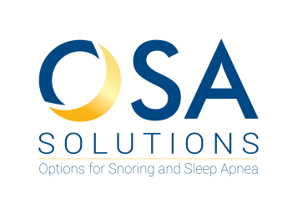
Dr. Cecilia Ng, DMD
#603 – 1788 West Broadway
Vancouver, BC V6J 1Y1
604-318-8633

Referral For Oral Appliance Therapy

Patient Name: _______________________________ DOB (dd/mm/yy): ___________________________

Pt Phone: ___________________________________ Pt Cell: ___________________________________

Address: ______________________________ City: ________________ Postal Code: ____________

DIAGNOSIS: (Please Check)

Obstructive Sleep Apnea Insomnia du to Sleep Apnea
UARS Hypersomnia due to Sleep Apnea
Primary Snoring Other: ___________________
MEDICAL JUSTIFICATION:

Unable to tolerant mask/strap/pressure
Reasons the patient cannot tolerate CPAP: ____________________________________
Other: ________________________________________

Statement of Medical Necessity
This above patient has undergone a sleep study and was diagnosed with obstructive sleep apnea. Obstructive sleep apnea is a medical condition which requires treatment. CPAP is a treatment option but this patient is cannot tolerate CPAP. Therefore, it is a medical necessity to treat this patient for this medical condition using an Oral Appliance as an alternative to CPAP.

Physician Name: _________________________
Physician Signature: ______________________
Date: ________ / ___________ / ___________

______________________________
Office Stamp

Please fax this form to 604-608-9331
or email to info@osasolutions.ca

